SUBASHREE.N-192521377
LAB EXPERIMENTS
EXP 15: DCL COMMANDS: GRANT, REVOKE
OUTPUT:
1:
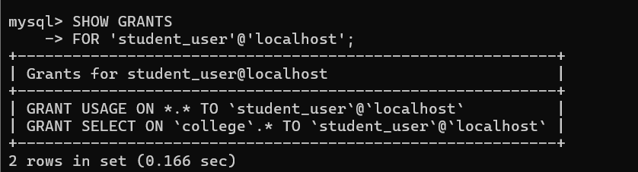
2:
